**GEN AI**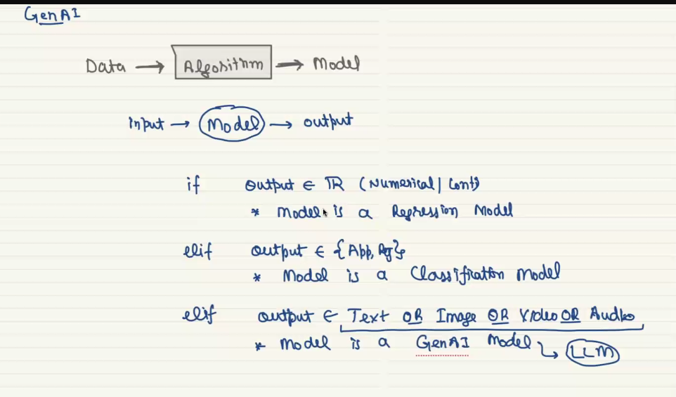

Transformers is the algorithm that helps to build gen ai, transformers will build large language model (LLMS). Size of the model will be huge in LLM, we can also say large and complex no of parameter

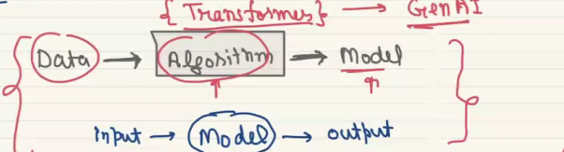

It takes text data and gives it’s output as text, so LLM is called language mode. A model that gives videos as it’s output are called large computer vision model or Large vision model

**WHAT IS LLM?**

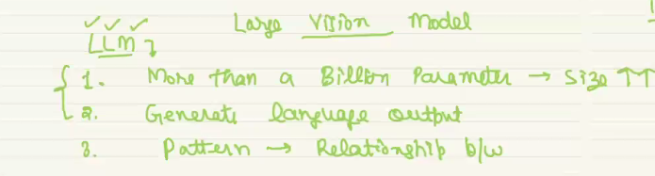

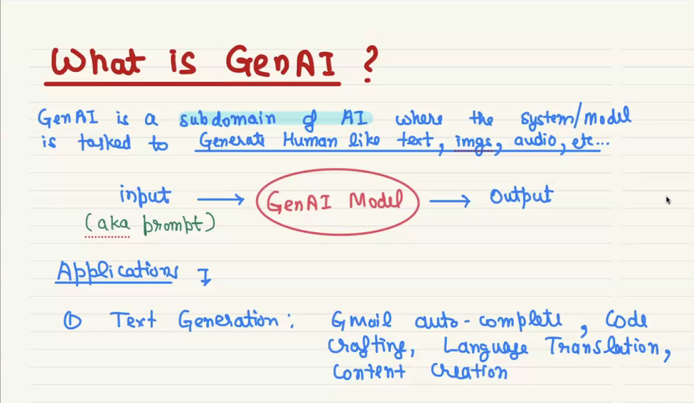

An input provided to the model is called prompt, and that is then called as prompt engineering, it is very helpful to learn model in good way, if the feeded data is not well the output will not will

All the AI website like chatgpt uses a model inside it, that model can be used to build a website like chatgpt.

Build a model like a model used on chatgpt is very expensive

**Steps to build GenAi applications**

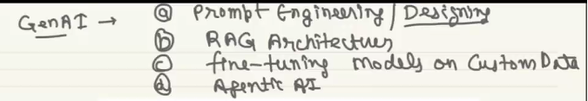

**ARCHITECTURE OF TRANSFORMS**

